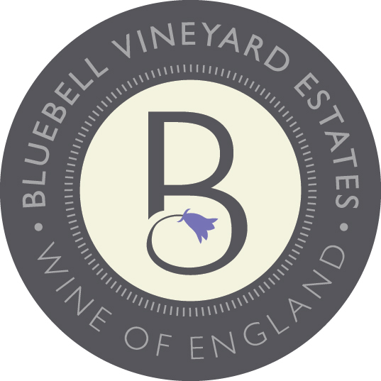
Vintage report

The 2020 season started well with no frost making perfect conditions for budburst. Ideal growing conditions continued throughout flowering and veraison. Harvest started a week later than in previous years and continued through until the 4^{th of} November. Conditions for harvest were dry and the fruit was picked with quality remaining high.

Technical information

Chardonnay 100%

From an early block of Chardonnay, the grapes are picked, crushed and de-stemmed. It is then fermented in 7–8-year-old Burgundy barrels to age for at least 5 to 7 months. Then racked and blended into stainless steel tank for 2-3 months giving the wine time to integrate and settle. It is then bottled.

Alcohol 12% vol
Residual Sugar 1.5 g/l
Total Acidity 5.9 g/l
pH 3.35
Malolactic MLF

Bottled 19th August 2021
Fermentation temperature 12-14 degrees
Length of fermentation 13 to 15 days

BLUEBELL VINEYARD ESTATES ‘ASHDOWN’ 2020 VALLEY VIEW
VEGAN FRIENDLY
Technical and Tasting Notes

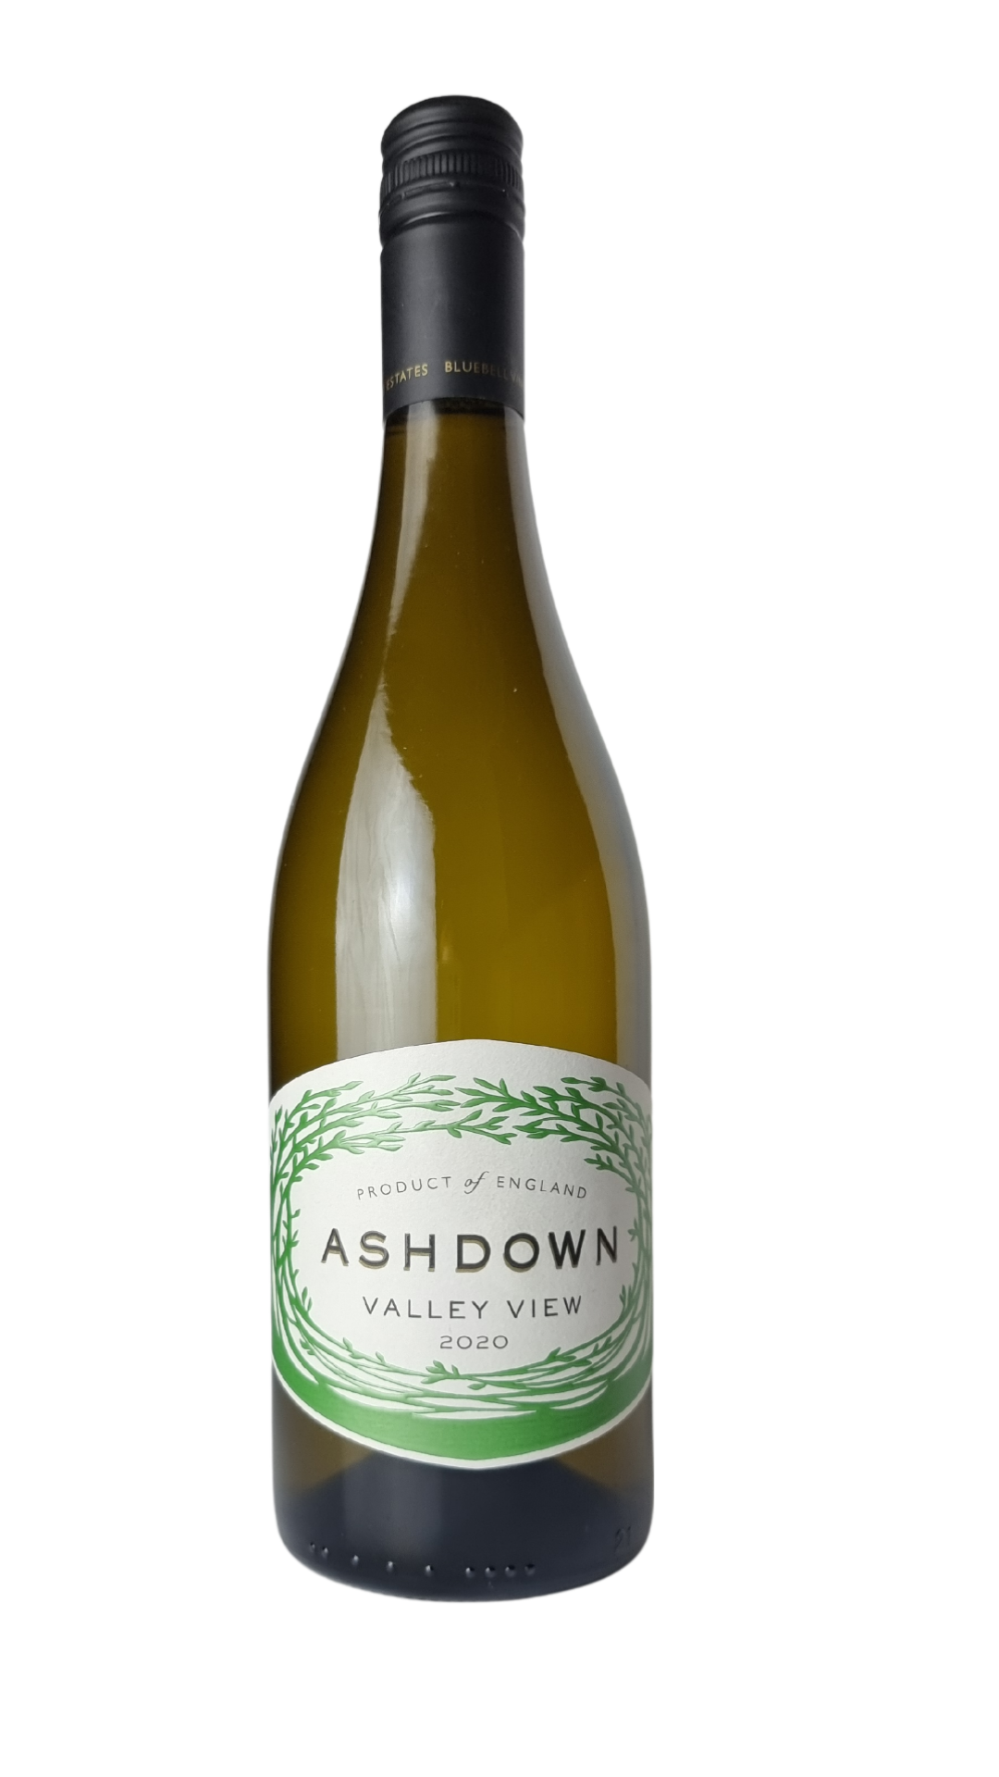
Bluebell Vineyard Estates
Situated on the edge of the Ashdown Forest near the famous Bluebell Steam Railway in Sussex, Bluebell Vineyard Estates is home to the award-winning range of ‘Hindleap’ English Sparkling Wines. Established in 2005, ‘Hindleap’ sparkling wines are terroir-driven, bottle-fermented, vintage sparkling wines.

Tasting Note

Delicate aromas of green apple, hazelnut and baked apricot pastry are complemented by notes of vanilla custard, melon, and lemon. This wine has a lovely creamy character with great acidity and a mild oaky finish.

