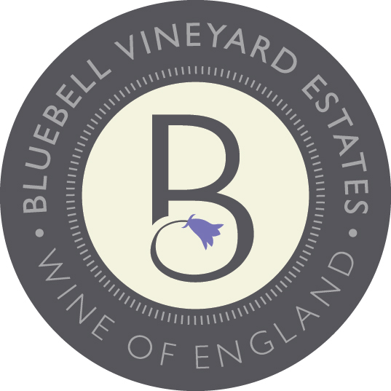
Vintage report

The 2019 growing season started well with growing conditions throughout the season being favourable. Warm dry weather persisted through much of June & July, leading to perfect conditions for flowering and fruit set. Conditions for ripening started well for the first few weeks in September, however, due to a considerable amount of wet weather in October the harvest proved difficult, and we had to quickly adapt schedules to bring in fruit.

Technical information

Pinot Meunier 100%

Alcohol 11.5 % vol
Residual Sugar 11g/l
Total Acidity 10.11g/l
pH 3
Malolactic No MLF

Bottled 29th April 2020
First disgorged 26th April 2022
Minimum time on lees 24 months
Fermentation temperature 12- 14 degrees
Length of fermentation 15 to 20 days

BLUEBELL VINEYARD ESTATES ‘HINDLEAP’ 2019 Pinot Meunier
VEGAN FRIENDLY
Technical and Tasting Notes

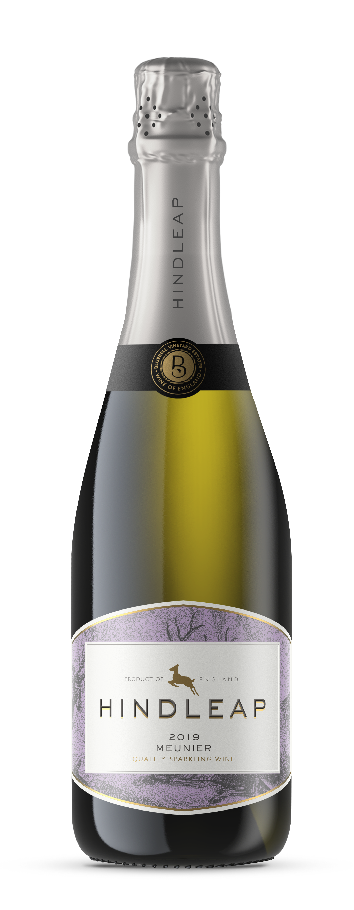

Tasting Note

Aromas of blackberry, cherry, raspberry, and Truffle leading to soft meringue, creamy nectarine, and raspberry yoghurt on the palate.
Bluebell Vineyard Estates
Situated on the edge of the Ashdown Forest near the famous Bluebell Steam Railway in Sussex, Bluebell Vineyard Estates is home to the award-winning range of ‘Hindleap’ English Sparkling Wines. Established in 2005, ‘Hindleap’ sparkling wines are terroir-driven, bottle-fermented, vintage sparkling wines.

