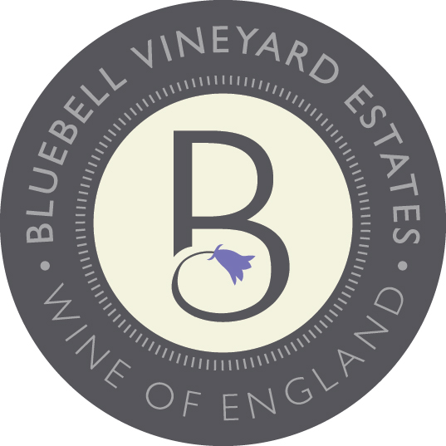
Vintage report

Due to a late frost in April, we were heavily frosted in 2017. We lost 75% of canopy so this is one of only 2 wines we were able to produce from this vintage. Despite this the growing season was relatively warm and dry. Due to this the fruit, we didn’t lose ripened beautifully.

Technical information
Chardonnay 100%
Alcohol 11.5%
Residual Sugar 7.5g
Total Acidity 12g
pH 3.17
Malolactic MLF

Bottled 08.08.2018
First disgorged 17.09.2021
Minimum time on lees 37 months

Ageing in barrel 7 months
Age of oak barrels 4-5 year old, French Oak

BLUEBELL VINEYARD ESTATES ‘HINDLEAP’ 2017 BARREL AGED BLANC DE BLANCS
VEGAN FRIENDLY
Technical and Tasting Notes

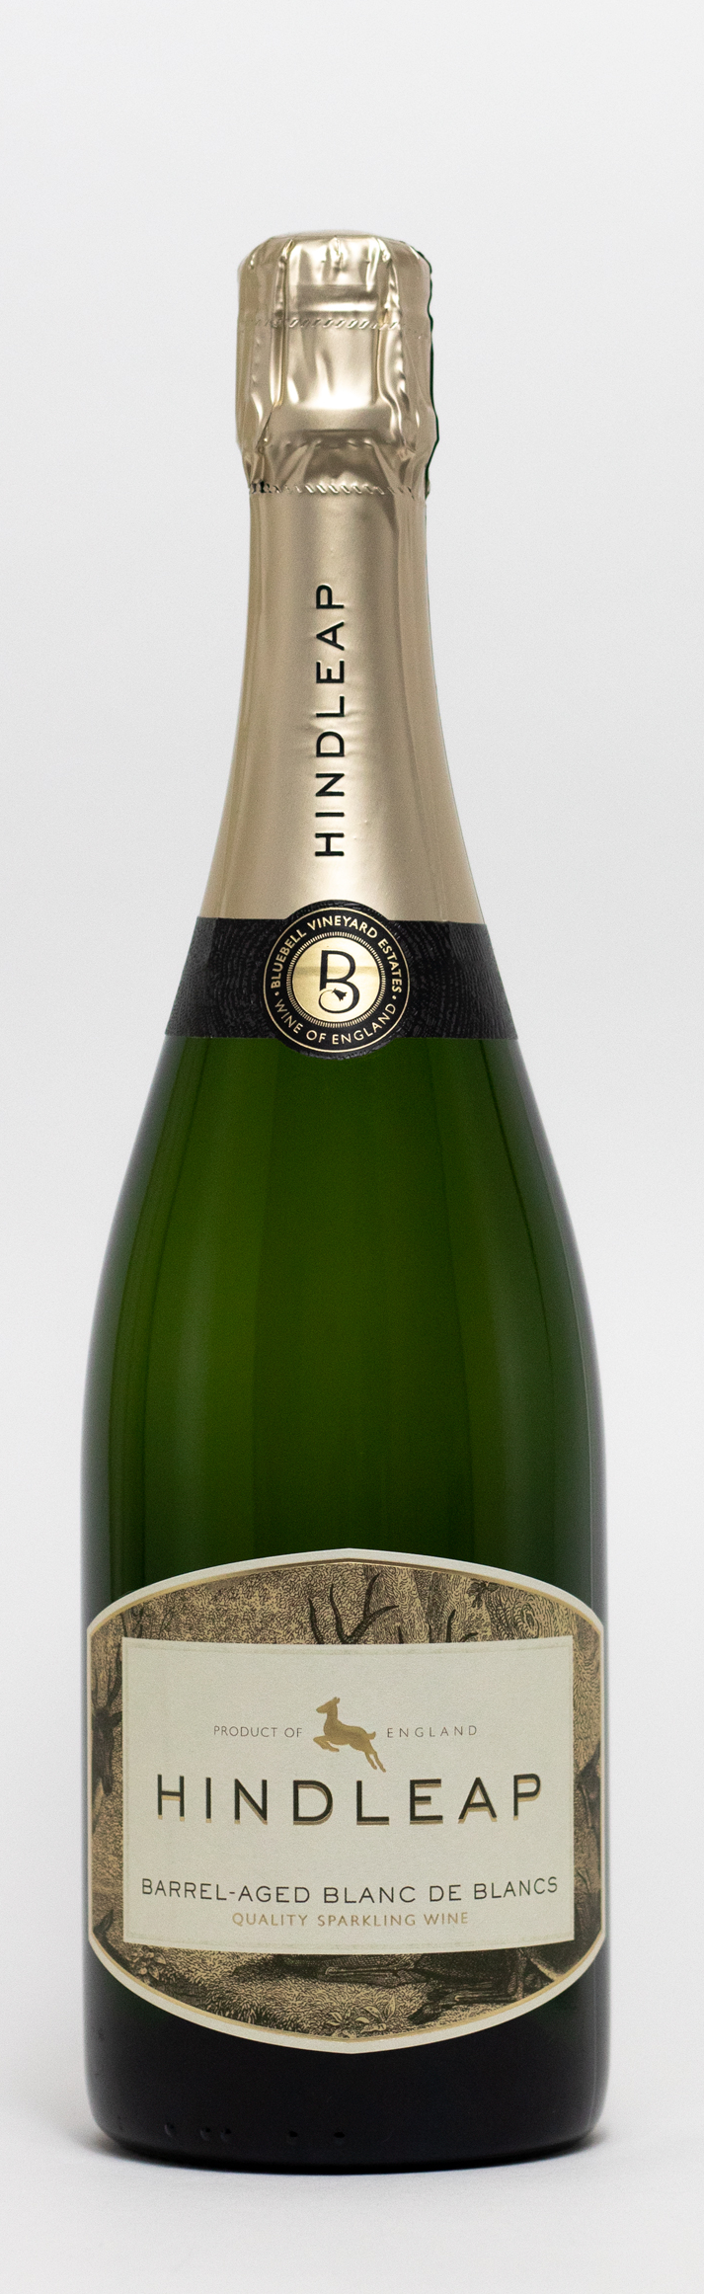

Tasting note

Buttery aromas of vanilla and nectarine give way to lively flavours of lime, orange, and white melon with a hazelnut finish This wine has a smooth, creamy, rounded long finish.
Bluebell Vineyard Estates
Situated on the edge of the Ashdown Forest near the famous Bluebell Steam Railway in Sussex, Bluebell Vineyard Estates is home to the award-winning range of ‘Hindleap’ English Sparkling Wines. Established in 2005, ‘Hindleap’ sparkling wines are terroir-driven, bottle-fermented, vintage sparkling wines.

