**Specification for Nduja**

Nduja is a soft spreadable Italian salami, from a traditional Calabrian recipe. Cobble Lane Cured has developed their Nduja using British meat and our favourite chilies from around the world.

**Ingredients**- British Pork Belly & Pork Fat (92%), Hungarian Paprika, Salt, Aleppo Chilli, Dextrose, Sodium Ascorbate. Preservatives E250, E252 (Pork content 125g per 100g)

**Allergens-** There are no allergens in this product.

**Preservatives**- E250 Sodium Nitrite, E252 Potassium Nitrate

**Product Photos:**

Whole packed nduja approx 1.3kgs half nduja unpacked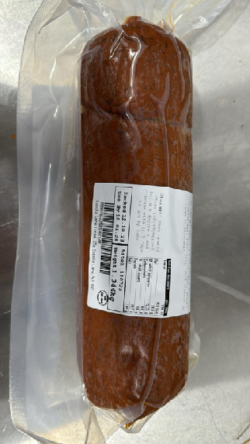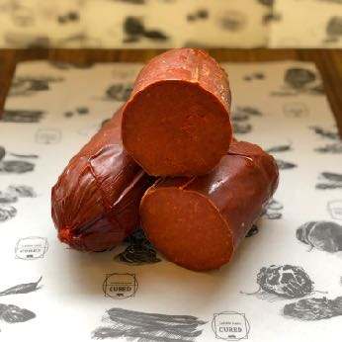

6 x 50g packs 1 x 100g unpacked 1 x 100g packed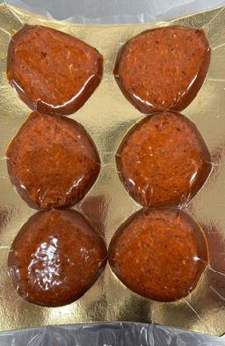

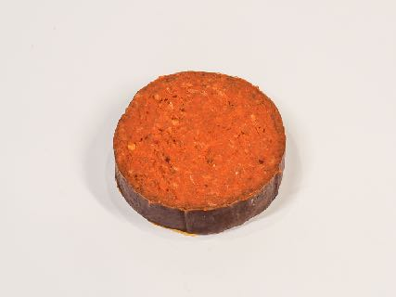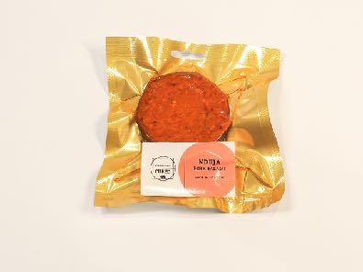

**Nutritional-**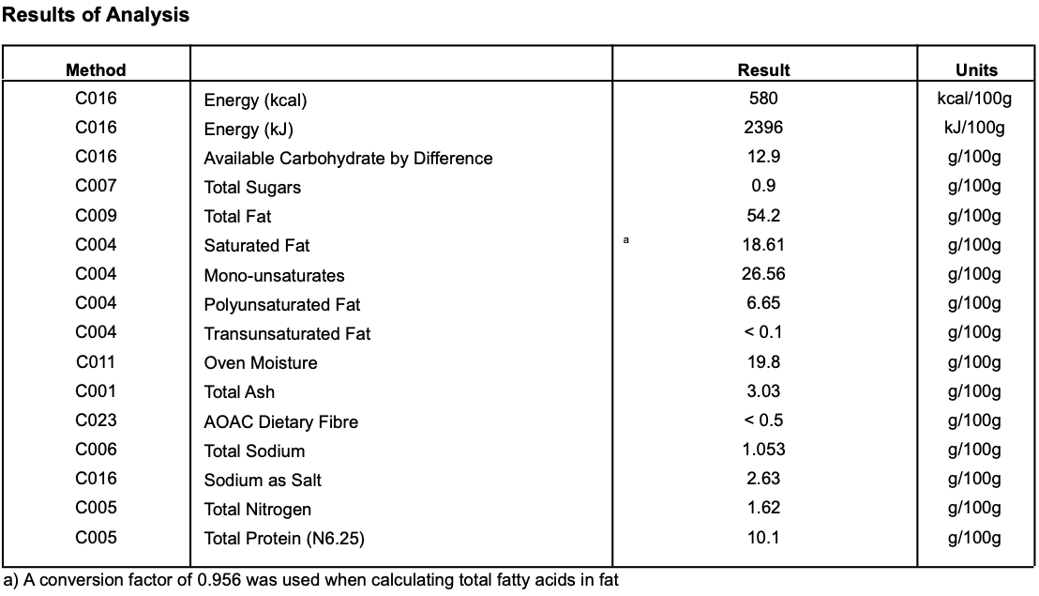

**Meat Supplier**-

Dawkins (GB 2410 & UK 2252)

Dawkins International Ltd is a UK Sow Processor. Established in the 1960’s, they are a family business in the true sense of the word; they are a real family! Together they have championed the need for high animal welfare within the industry which has allowed them to develop into a successful, medium-sized company. With the family friendly culture, they pride themselves on taking a professional approach, adopting an ‘act now’ attitude in everything they do.

**Date Code Format and Traceability -** Date- DD/MM/YYYY Batch Code- 300316

**Storage once opened**- Keep refrigerated. Sealed in a vacuum sealed pack. Once opened store refrigerated below 8 degree C and consume with in 7 days, Or use by date

**Microbiological Testing**- Carried out By Intertek Laboratories

**Micro Standard-**

E.Coli <10 Staphylococci <20

Enterobacteriaceae <10 Bacillius Cerus <20

Clostridium <10

Listeria Not Detected Salmonella Not Detected

**Packaging-**  The Nduja is packaged in High quality food standard vacuum bags 50cm, 20cm, 10cm.The outer packaging is a Cardboard box 50cm, 40cm, 28cm

**Shelf life**- max 6 months, min 2 Months from Pack Date. (The Lab testing approval as a ready to eat product is actually good for at least 12 months)

**Pack size & code**- Approx 1.3KG whole pouch. Product Code CLC17

**Also available as:**

* 100g deli packs. Product Code CLC112 Packed in high quality food grade boards & bags. Size approx 160mmx250mm. Shelf life max 60 days months, min 50 days. Once opened store refrigerated below 8 degree C and consume with in 3 days, Or use by date.
* 6 x 50g packs (total 300g). Product Code CLC230. Packed in high quality food grade boards & bags. Size approx 220mmx280mm . Shelf life max 60 days months, min 55 days. Once opened store refrigerated below 8 degree C and consume with in 3 days, Or use by date.
* Approx 650g half pouches. Product Code CLC213 The Nduja is packaged in High quality food standard vacuum bags 50cm, 20cm, 10cm.The outer packaging is a Cardboard box 50cm, 40cm, 28cm. Shelf life max 6 months min 2 Months from Pack Date.