**Specification for Bresaola Whole Pieces**

Bresaola is a cured and matured cut from the topside of beef. It is matured for a minimum 2 months.

**Ingredients -** British Beef Silverside (96.3%), Salt, Spices (0.4%), Cane Sugar. Preservatives: E250 E252. (Beef content 143g per 100g)

**Allergens -** There are no allergens in this product.

**Preservatives**- E250 Sodium Nitrite, E252 Potassium Nitrate

**Nutritional Report:**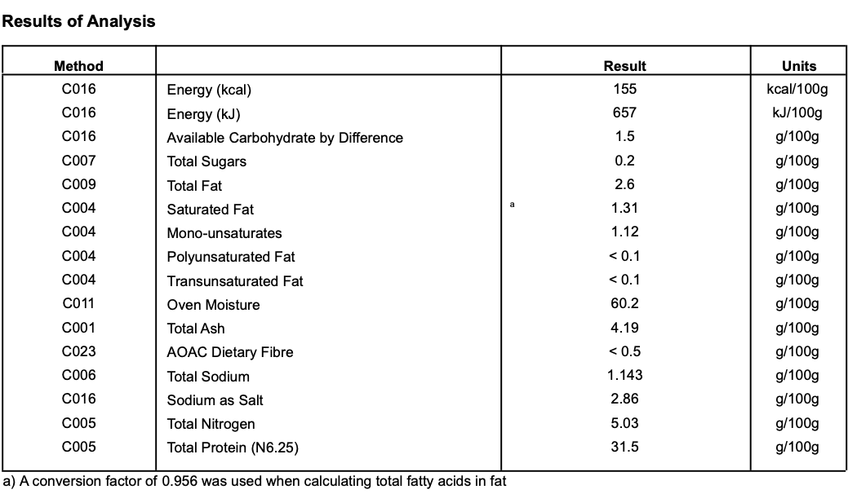

**Meat Supplier** - Dunbia Meats (UK 5106)

Dunbia have been producing UK quality beef and lamb products for over 40 years for multiple retailers, foodservice outlets and wholesalers throughout the UK. They operate with the strictest of standards in relation to animal welfare, food safety and technical quality from farm to fork. Their production systems use the very latest in modern technology, enabling them to operate advanced slaughter and de-boning processes.

**Date Code Format and Traceability -** Date- DD/MM/YYYY Batch Code- 300316

**Storage once opened**- Keep Refrigerated. Sealed in a vacuum sealed pack. Once opened store refrigerated below 8 degree C and consume with in 7 days, Or use by date

**Packaging -** Bresaolais packaged in High quality food standard vacuum bags 50cm, 30cm, 10cm.The outer packaging is a Cardboard box 40cm, 40cm, 30cm

**Microbiological Testing**- Carried out By Intertek Laboratories

**Micro Standard-**

E.Coli <10 Staphylococci <20

Enterobacteriaceae <10 Bacillius Cerus <20

Clostridium <10

Listeria Not Detected Salmonella Not Detected

**Shelf life**- max 6 months min 3 Months from Pack Date

**Pack size**- Whole approx 1.5kgs-2.5kg (can be supplied in half pieces)

**Also available as:**

* 60g sliced packs. Packed in high quality food grade boards & bags. Size approx 160mmx250mm. Shelf life max 61 days months, min 56 days. Once opened store refrigerated below 8 degree C and consume with in 3 days, Or use by date
* 100g, 250g & 500g sliced packs. Packed in high quality food grade boards & bags. Size approx 250mmx350mm. Shelf life max 31 days, min 27 days. Once opened store refrigerated below 8 degree C and consume with in 3 days, Or use by date