Our Bresaola starts with the selection of the finest British silverside o beef, ensuring only the highest quality, locally sourced meat is used. The cuts are prepared with a traditional recipe of herbs and spices, which give a refreshing tangy flavour and air-dried in our maturation chambers for 2-3 months until succulent . Originating from the the Lombardy region in Italy, this is a great way to experience lean British beef.The perfect choice to snack on its own or with a drizzle of olive oil,  great on a sharing platter to enjoy with drinks or as a really punchy filling for a decadent sandwich.

**Specification for Bresaola whole pieces**

Bresaola is a cured and matured cut from the topside of beef. The weight is variable, generally 1.5 to 2.5kgs It is matured for a minimum 2 months.

**Ingredients -** British Beef Silverside (96.3%), Salt, Spices (0.4%), Cane Sugar. Preservatives: E250 E252. (Beef content 143g per 100g)

**Allergens -** There are no allergens in this product.

**Preservatives**- E250 Sodium Nitrite, E252 Potassium Nitrate.

**Nutritional Report:**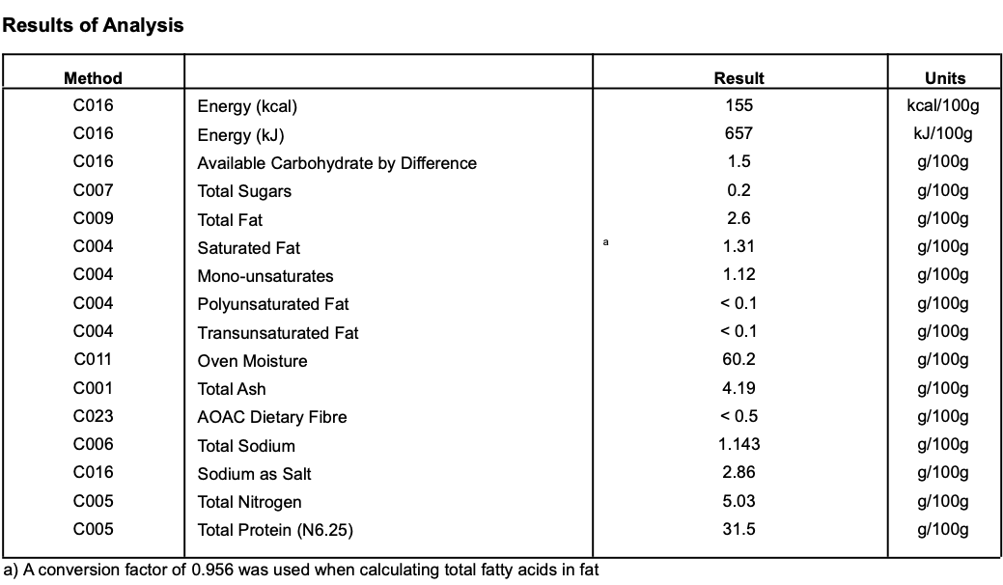

**Meat Supplier** - Dunbia Meats (UK 5106)

Dunbia have been producing UK quality beef and lamb products for over 40 years for multiple retailers, foodservice outlets and wholesalers throughout the UK. They operate with the strictest of standards in relation to animal welfare, food safety and technical quality from farm to fork. Their production systems use the very latest in modern technology, enabling them to operate advanced slaughter and de-boning processes.

**Date Code Format and Traceability -** Date- DD/MM/YYYY Batch Code- 300316

**Storage once opened**- Keep Refrigerated.

**Shelf life**- max 6 months min 3 Months from Pack Date

**Pack size**- Whole approx 1.5kgs-2.5kg (can be supplied in half pieces)

**Packaging -** Bresaolais packaged in High quality food standard vacuum bags 50cm, 30cm, 10cm.The outer packaging is a Cardboard box 40cm, 40cm, 30cm

**Microbiological Testing**- Carried out By Intertek Laboratories

**Micro Standard-**

E.Coli <10 Staphylococci <20

Enterobacteriaceae <10 Bacillius Cerus <20

Clostridium <10

Listeria Not Detected Salmonella Not Detected