Our take on the classic Italian finocchiona salami, typical of the Tuscany region. Made from British pork, and characterised by the use of fennel seeds, it has a fresh and clean fennel fragrance rounded out with a little red wine and garlic. Hung for at least 5-6 weeks for a moist subtle texture. This is our most popular meat that we produce and has won many awards over the years..

Specification for Fennel & Garlic Salami
This Salami is our version of a classic Italian Finocchiona, a soft flavoursome salami perfect for charcuterie boards or pizza. Whole sticks of approx 2kgs. For the Whole product it is suggested to peel off the casing before slicing. The product will have mould on the casing, which we add & is necessary for the curing process. Once peeled, this will leave a fresh, perfect salami underneath.

Ingredients- British Pork & Pork Back Fat (96%), Salt, Red Wine (1.0%), Spices (1.0%), Dextrose, Garlic (0.2%). Preservatives: E250 E252. (Pork content 143g per 100g)

Preservatives- E250 Sodium Nitrite, E252 Potassium Nitrate

Allergens- There are no allergens in this product.

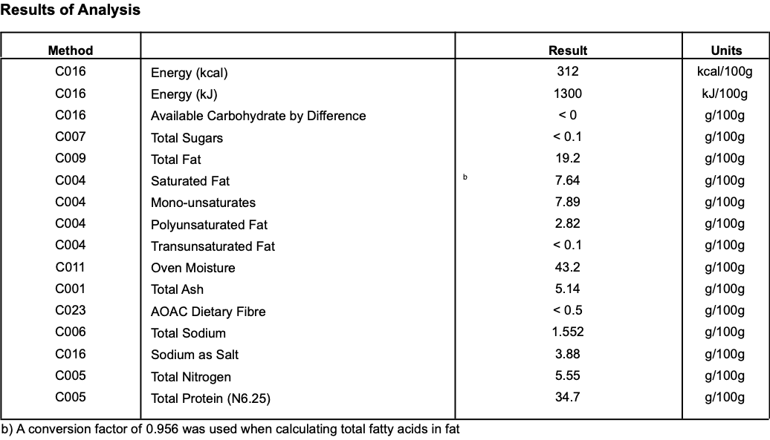
Nutritional-

Meat Supplier- Dawkins International (GB 2410 & UK 2252)
Dawkins International Ltd is a UK Sow Processor. Established in the 1960’s, they are a family business in the true sense of the word; they are a real family! Together they have championed the need for high animal welfare within the industry which has allowed them to develop into a successful, medium-sized company. With the family friendly culture, they pride themselves on taking a professional approach, adopting an ‘act now’ attitude in everything they do.

Date Code Format and Traceability - Date- DD/MM/YYYY Batch Code- 300316

Storage once opened- Keep Refrigerated. Sealed in a vacuum pack. Once opened store refrigerated below 8 degree C and consume with in 7 days, Or use by date.

Packaging - The Salami is packaged in High quality food standard vacuum bags 50cm, 20cm, 10cm. The outer packaging is a Cardboard box 40cm, 40cm, 30cm

Microbiological Testing- Carried out By Intertek Laboratories

Micro Standard-

E.Coli <10 Staphylococci <20
Enterobacteriaceae <10 Bacillius Cerus <20
Clostridium <10
Listeria Not Detected Salmonella Not Detected

Shelf life- max 6 months, min 3 Months from Pack Date

Pack size- Whole sticks approx 2.0kg

