A large fresh flavoured salami typical of Calabria in the South Western region of Italy is made with coarsely minced British Pork leg, creamy fat, and mixed with a selection of sweet medium-heat chillies as well as Hungarian paprika. It is hung & air-dried for 5-6 weeks in order to develop the subtle flavours. The name Soppressata is derived from the practice of pressing the salami between pieces of wood resulting in a straight, rectangular flattened shape. Our recipe is our own unique take on a combination of both Spianata and Soppressata, and is round in shape; hence the name N1 which is derived from our postcode in Islington in North London.

**Specification for N1 Soppressata Salami**

Fermented & air-dried sausage with spices in an inedible casing. Flavoured with the classic Italian flavours of the tradition Spianata Salami. For the Whole product it is suggested to peel off the casing before slicing. The product will have mould on the casing, which we add & is necessary for the curing process. Once peeled, this will leave a fresh, perfect salami underneath.

**Ingredients**- British Pork (95.1%), Salt, White Wine (1.0%), Spices (0.8%), Sweet Paprika, Dextrose, Garlic (0.1%). Preservatives: E250 E252. (Pork content 143g per 100g)

**Preservatives**- E250 Sodium Nitrite, E252 Potassium Nitrate

**Allergens-** There are no allergens in this product.

**Nutritional-**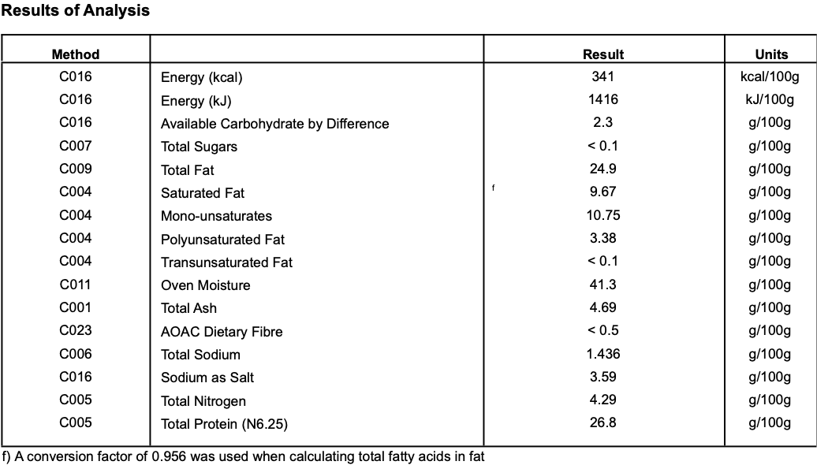

**Meat Supplier**- Dawkins International (GB 2410 & UK 2252)

Dawkins International Ltd is a UK Sow Processor. Established in the 1960’s, they are a family business in the true sense of the word; they are a real family! Together they have championed the need for high animal welfare within the industry which has allowed them to develop into a successful, medium-sized company. With the family friendly culture, they pride themselves on taking a professional approach, adopting an ‘act now’ attitude in everything they do.

**Date Code Format and Traceability -** Date- DD/MM/YYYY Batch Code- 300316

**Storage once opened**- Keep Refrigerated. Sealed in a vacuum sealed pack. Once opened store refrigerated below 8 degree C and consume with in 7 days, Or use by date

**Packaging -** The Salamiis packaged in High quality food standard vacuum bags 50cm, 30cm, 10cm.The outer packaging is a Cardboard box 40cm, 40cm, 30cm

**Microbiological Testing**- Carried out By Intertek Laboratories

**Micro Standard-**

E.Coli <10 Staphylococci <20

Enterobacteriaceae <10 Bacillius Cerus <20

Clostridium <10

Listeria Not Detected Salmonella Not Detected

**Shelf life**- max 6 months min 3 Months from Pack Date

**Pack size**- Whole approx 2.0kg salamis