A simple salami ground with salt & tellicherry black pepper and a little garlic, giving a great balanced flavour letting the quality of the meat shine. Only the best British pork and fat is used. This is our take on a Napoli Salami, which is very similar also to the Milani style. It is hung and dried for 5 to 6 weeks in our maturation chambers.

**Specification for Salt and Pepper salami**

For the Whole product it is suggested to peel off the casing before slicing. The product will have mould on the casing, which we add & is necessary for the curing process. Once peeled, this will leave a fresh, perfect salami underneath.

**Ingredients**- British Pork (96.4%) Salt, Black Pepper, Dextrose, Garlic (0.1%). Preservatives: E250 E252. (Pork content 143g per 100g)

**Preservatives**- E250 Sodium Nitrite, E252 Potassium Nitrate

**Allergens-** There are no allergens in this product.

**Product Photos -**

Whole salami in 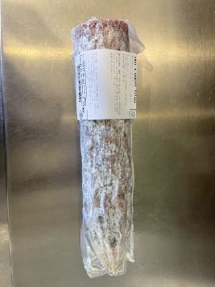packaging Whole salami in packaging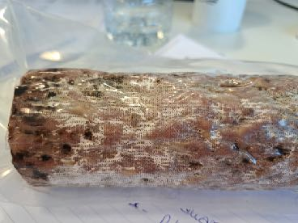 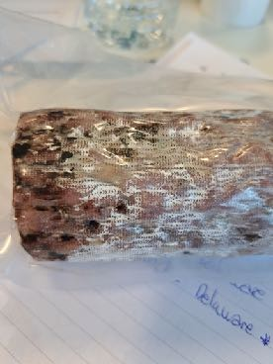Whole salami in packaging Whole salami unpacked Whole salami unpeeled 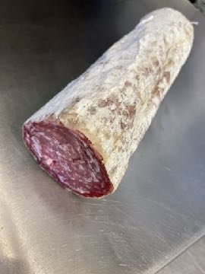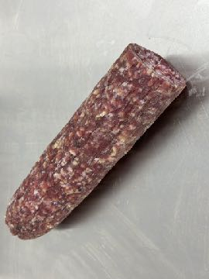

**Meat Supplier**- Dawkins International (GB 2410 & UK 2252)

Dawkins International Ltd is a UK Sow Processor. Established in the 1960’s, they are a family business in the true sense of the word; they are a real family! Together they have championed the need for high animal welfare within the industry which has allowed them to develop into a successful, medium-sized company. With the family friendly culture, they pride themselves on taking a professional approach, adopting an ‘act now’ attitude in everything they do.

**Date Code Format and Traceability -** Date- DD/MM/YYYY Batch Code- 300316

**Nutritional-**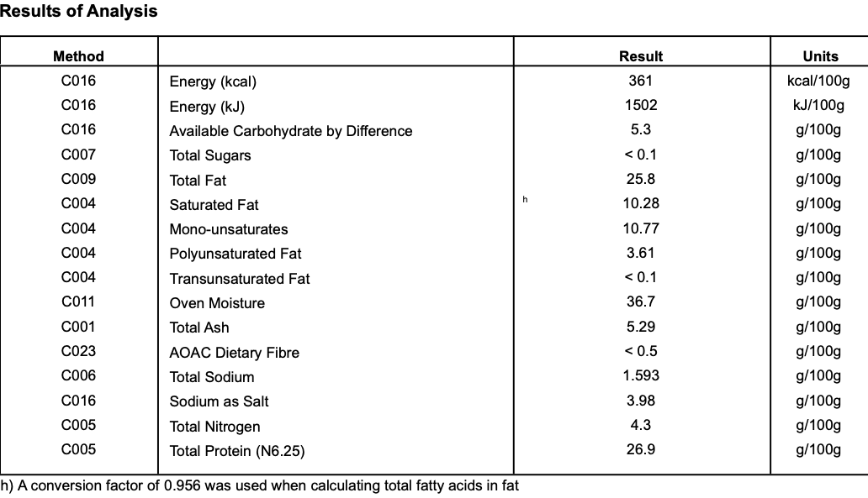

**Storage once opened**- Keep Refrigerated. Sealed in a vacuum sealed pack. Once opened store refrigerated below 8 degree C and consume with in 7 days, Or use by date

**Packaging -** The whole Salamiis packaged in High quality food standard vacuum bags 50cm, 20cm, 10cm.The outer packaging is a Cardboard box 40cm, 40cm, 30cm

**Microbiological Testing**- Carried out By Intertek Laboratories

**Micro Standard-**

E.Coli <10 Staphylococci <20

Enterobacteriaceae <10 Bacillius Cerus <20

Clostridium <10

Listeria Not Detected Salmonella Not Detected

**Shelf life**- max 6 months, min 3 Months from Pack Date. Shelf life can be extended upon demand.

**Pack size**- Whole approx 2.0kg salamis