We make our Coppa real slow! Giving it as much time in our chamber as possible, up to 5 months to mature. This gentle aging process allows it to develop slowly, avoiding overdrying and to generate a rich fruity flavour, and soft marbled texture. We use retired breeding sows in our production, this gives us a far superior meat for charcuterie and is highlighted perfectly with the collars being not only twice the size as a standard collar but also having twice the marbling as a standard pig. Sows can be 4-5 years old and usually get exported to the continent so we are very proud to be providing a use in the UK. This cured marbled collar is a great showcase for flavoursome, well-raised British pork.

**Specification for Coppa**

A cured and matured collar of retired British pork sow, hung for a min of 12 weeks and flavoured with spices. Whole pieces approx 1.6kgs to 2.6kgs

**Ingredients**- British Pork Collar (95.1%) , Salt, Cane Sugar, Spices (0.3%), Garlic (0.1%). Preservatives: E250 E252. (Pork content 166g per 100g)

**Allergens-** There are no allergens in this product.

**Preservatives**- E250 Sodium Nitrite, E252 Potassium Nitrate

**Nutritional Report**

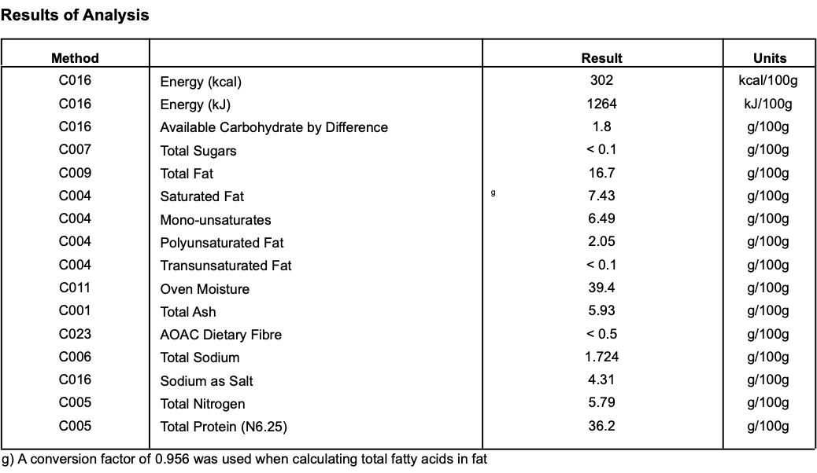

**Product Photos:**

Whole Coppa 1-2.5kgs packed Whole Coppa 1-2.5kgs unpacked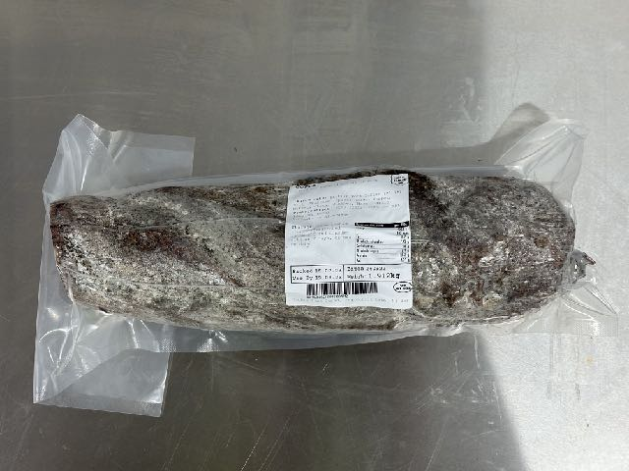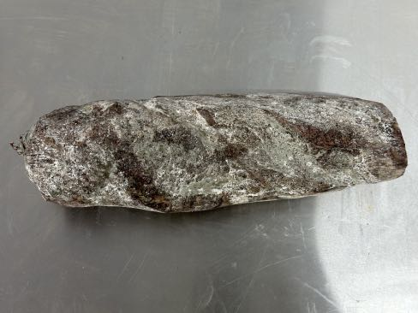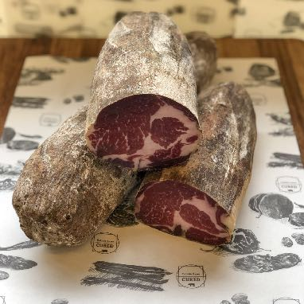

**Meat Supplier**- Dawkins International (GB 2410 & UK 2252)

Dawkins International Ltd is a UK Sow Processor. Established in the 1960’s, they are a family business in the true sense of the word; they are a real family! Together they have championed the need for high animal welfare within the industry which has allowed them to develop into a successful, medium-sized company. With the family friendly culture, they pride themselves on taking a professional approach, adopting an ‘act now’ attitude in everything they do.

**Date Code Format and Traceability -** Date- DD/MM/YYYY Batch Code- 300316

**Storage once opened**- Keep Refrigerated. Sealed in a vacuum sealed pack. Once opened store refrigerated below 8 degree C and consume with in 7 days, Or use by date.

**Packaging -** Coppais packaged in High quality food standard vacuum bags 50cm, 30cm, 10cm.The outer packaging is a Cardboard box 40cm, 40cm, 30cm

**Microbiological Testing**- Carried out By Intertek Laboratories

**Micro Standard-**

E.Coli <10 Staphylococci <20

Enterobacteriaceae <10 Bacillius Cerus <20

Clostridium <10

Listeria Not Detected Salmonella Not Detected

**Shelf life**- max 6 months min 3 Months from Pack Date

**Pack size**- Whole pieces approx 1.6kgs to 2.6kgs