A simple air dried British ham - using the eye of the pork loin (which is the area towards the back, between the shoulder and back legs) and is the leanest, most tender part of the animal. It is cured in salt before being rubbed with a little olive oil and flavoured smoked Spanish paprika and a little garlic & hung in a natural casing. The pork loin is wide and flat. It is matured as a boneless ham for 4 months, keeping it soft with bold flavour from the rub.

**Specification for Lomo**

A cured British Loin of pork, hung and dried for 12 weeks and flavoured with simple spices.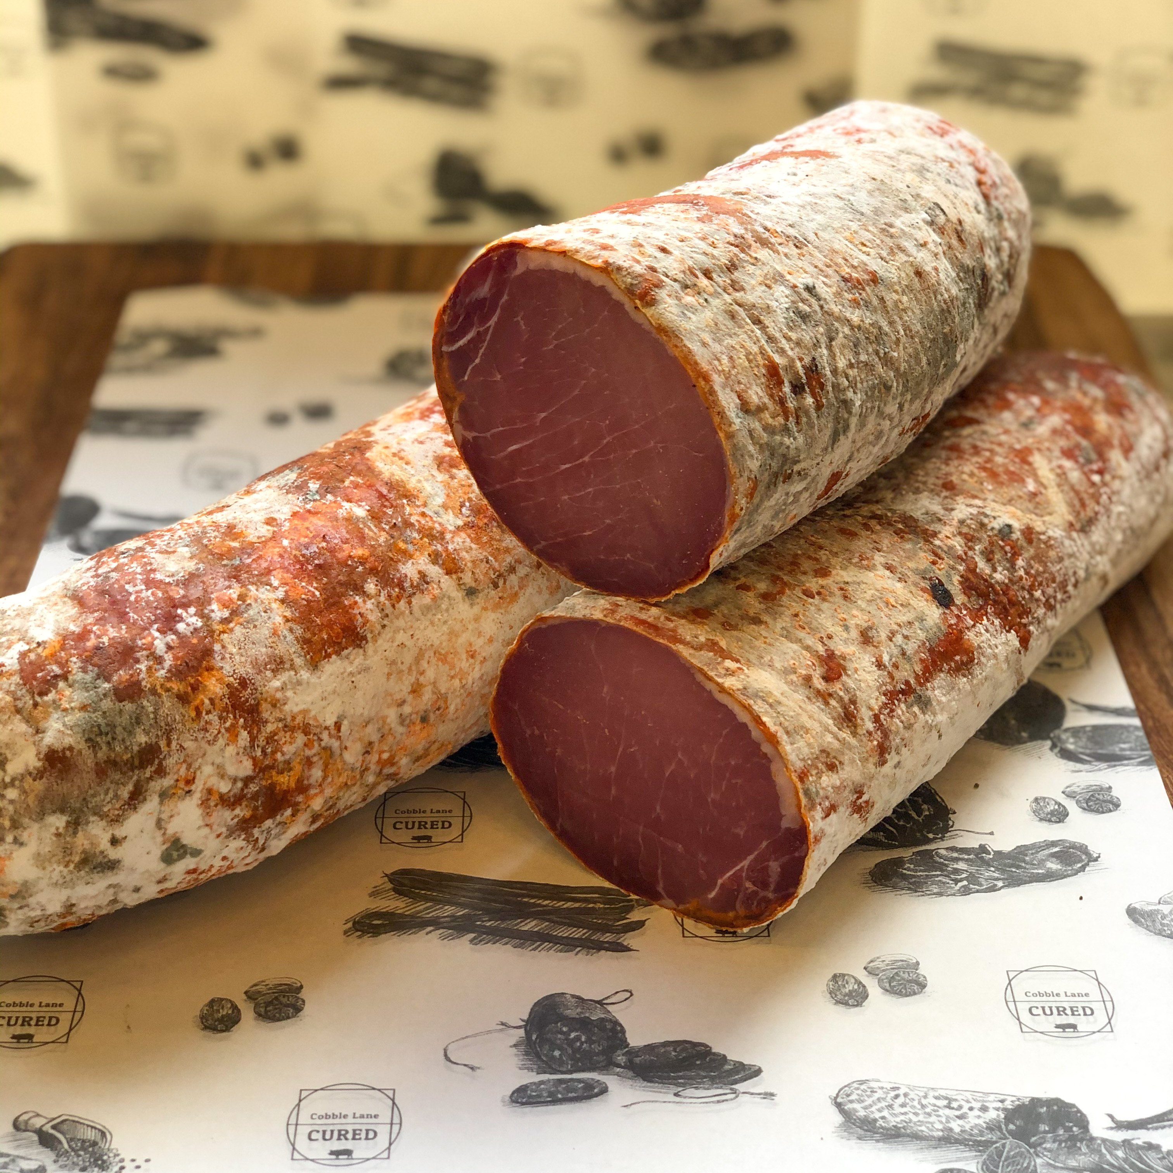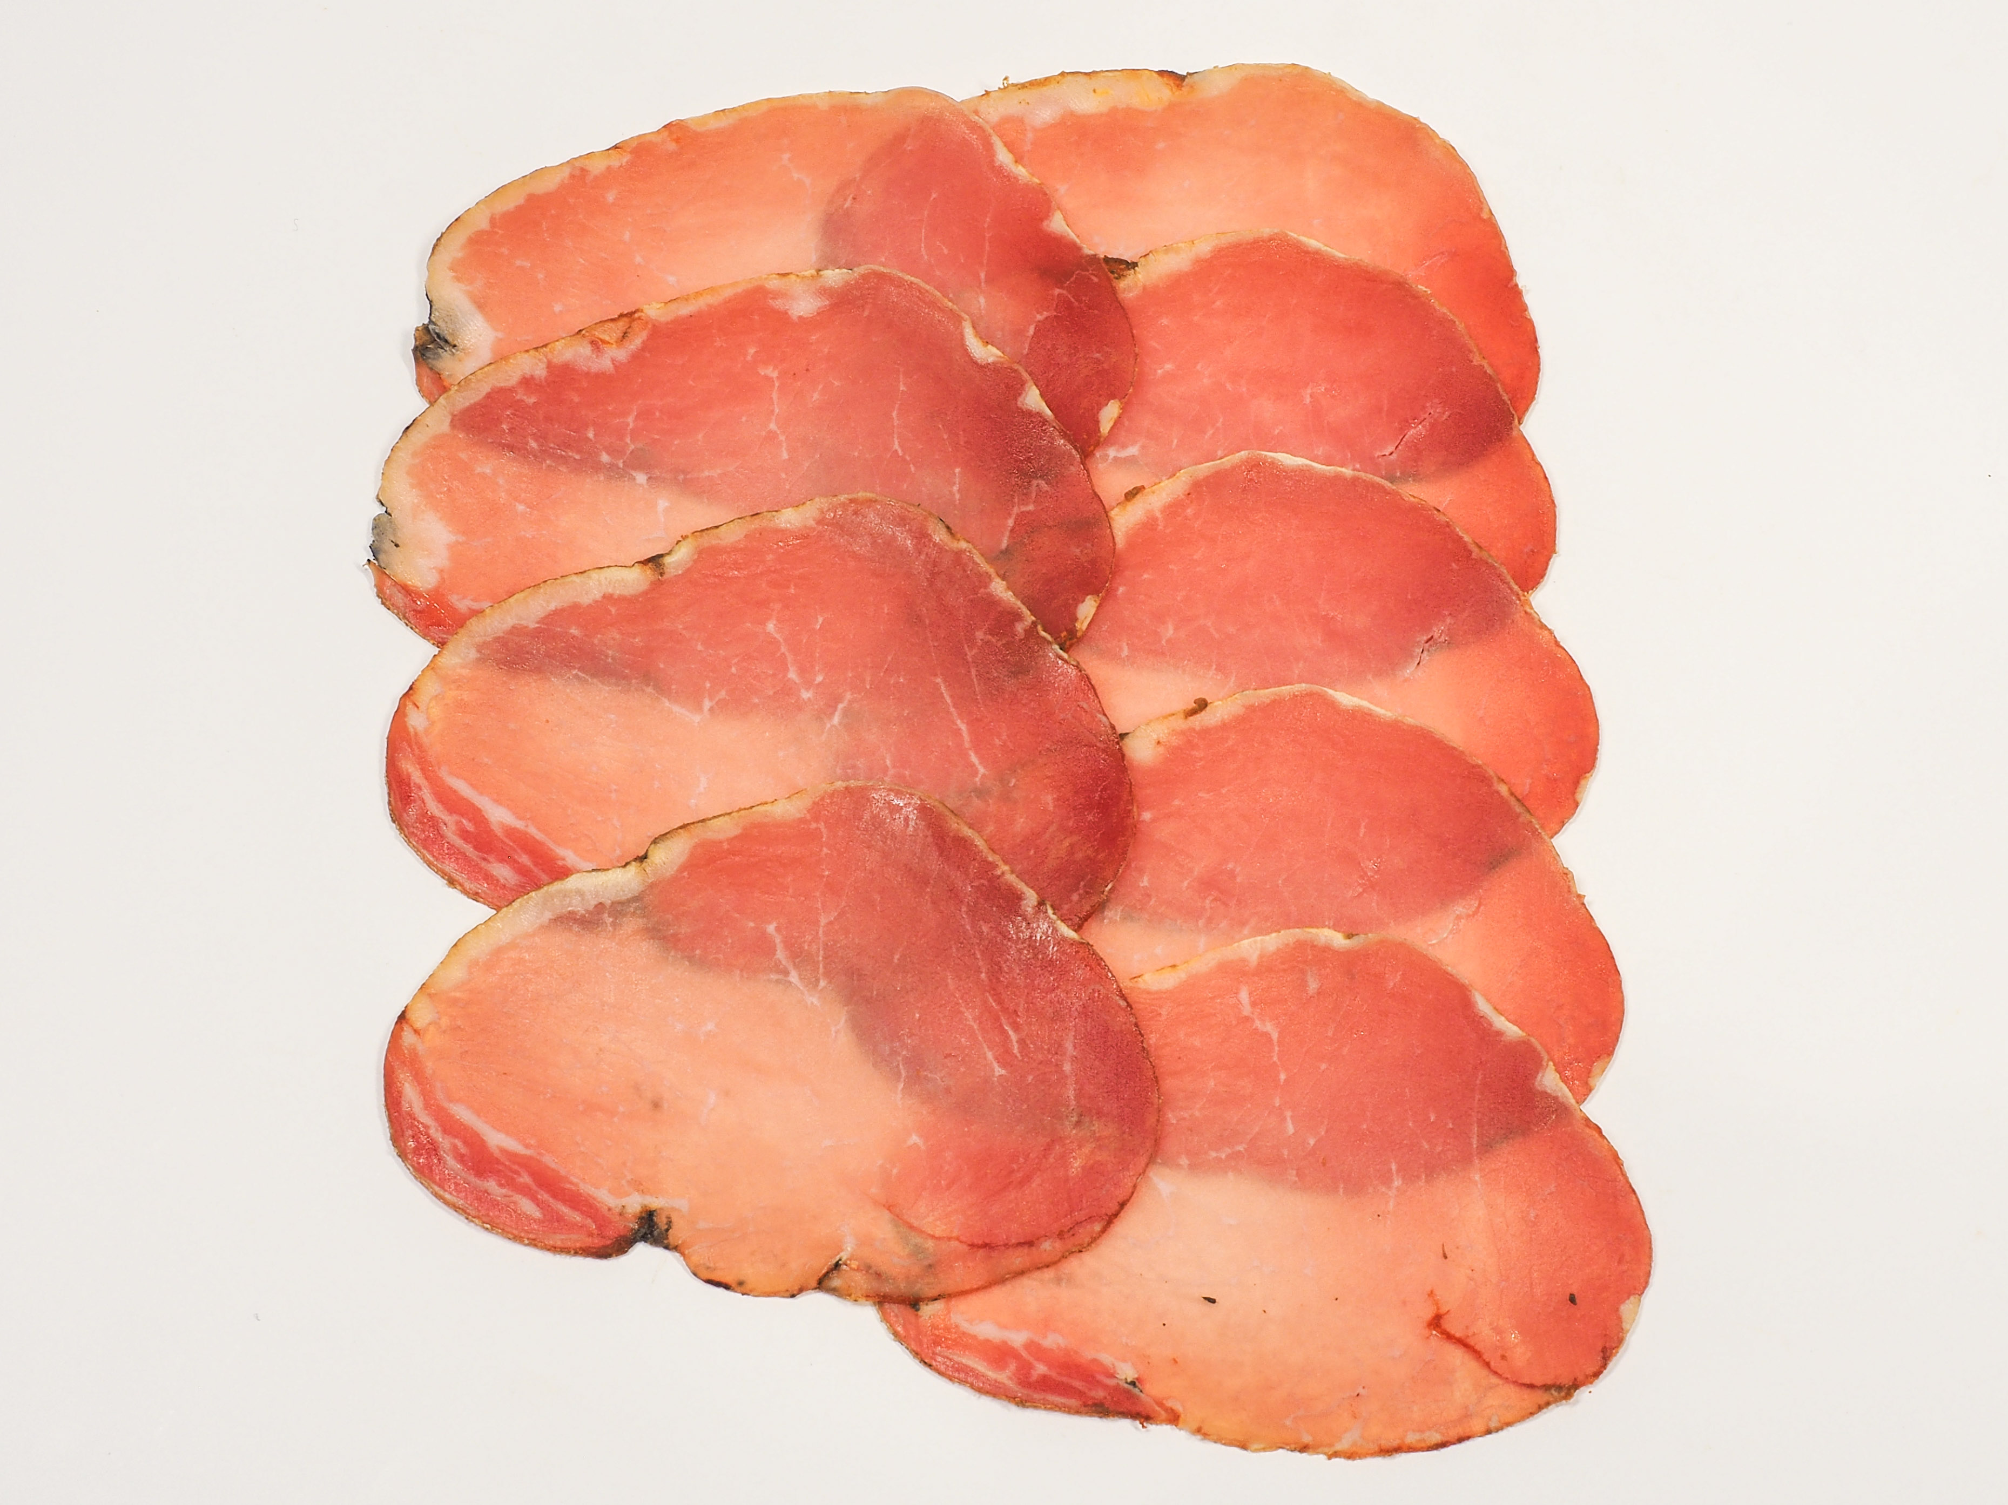

**Ingredients**- British Pork (95.1%), Salt, Spanish Paprika, Garlic (0.8%). Preservatives: E250 E252. (Pork content 143g per 100g)

**Allergens-** There are no allergens in this product.

**Preservatives**- E250 Sodium Nitrite, E252 Potassium Nitrate.

**Nutritional Report:**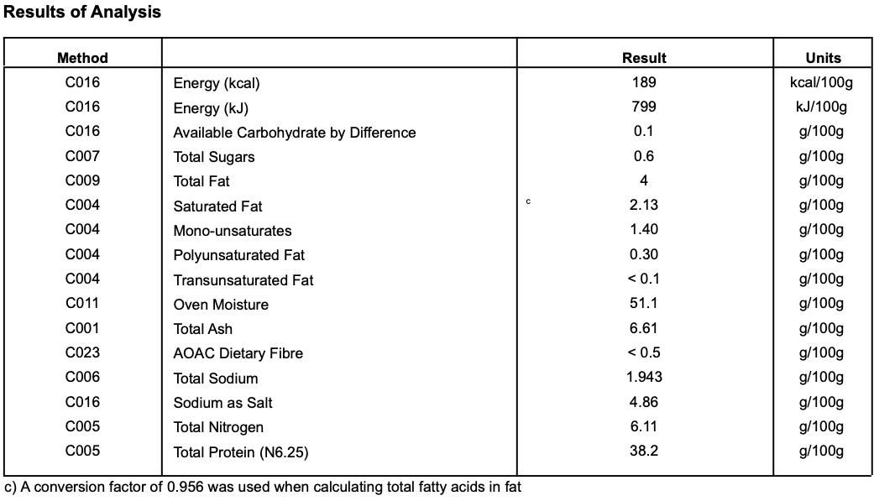

**Meat Supplier**- Dawkins International (GB 2410 & UK 2252)

Dawkins International Ltd is a UK Sow Processor. Established in the 1960’s, they are a family business in the true sense of the word; they are a real family! Together they have championed the need for high animal welfare within the industry which has allowed them to develop into a successful, medium-sized company. With the family friendly culture, they pride themselves on taking a professional approach, adopting an ‘act now’ attitude in everything they do.

**Date Code Format and Traceability -** Date- DD/MM/YYYY Batch Code- 300316

**Storage once opened**- Keep refrigerated. Sealed in a vacuum sealed pack. Once opened store refrigerated below 8 degree C and consume with in 7 days, Or use by date.

**Packaging -** Lomois packaged in High quality food standard vacuum bags 50cm, 30cm, 10cm.The outer packaging is a Cardboard box 40cm, 40cm, 30cm

**Microbiological Testing**- Carried out By Intertek Laboratories

**Micro Standard-**

E.Coli <10 Staphylococci <20

Enterobacteriaceae <10 Bacillius Cerus <20

Clostridium <10

Listeria Not Detected Salmonella Not Detected

**Shelf life**- max 6 months min 3 Months from Pack Date

**Pack size**- Whole approx 1.5kgs to 1.8kgs