**Specification for Pancetta**

Made from British reared Pork Belly, cured with pepper and rosemary and then hung and air dried in our maturation chamber for 10-12 weeks. This Italian style of meat has a light and silky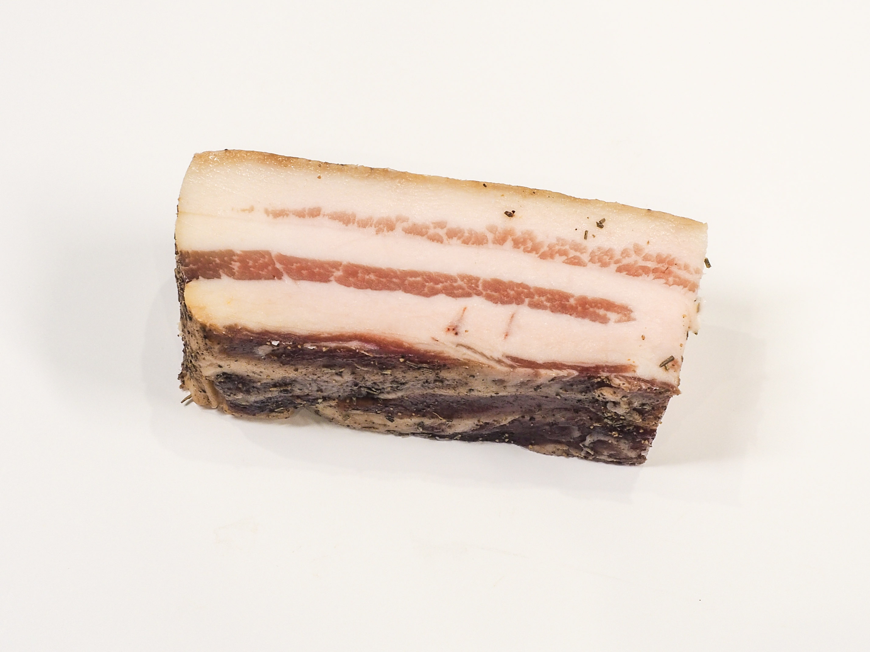 texture.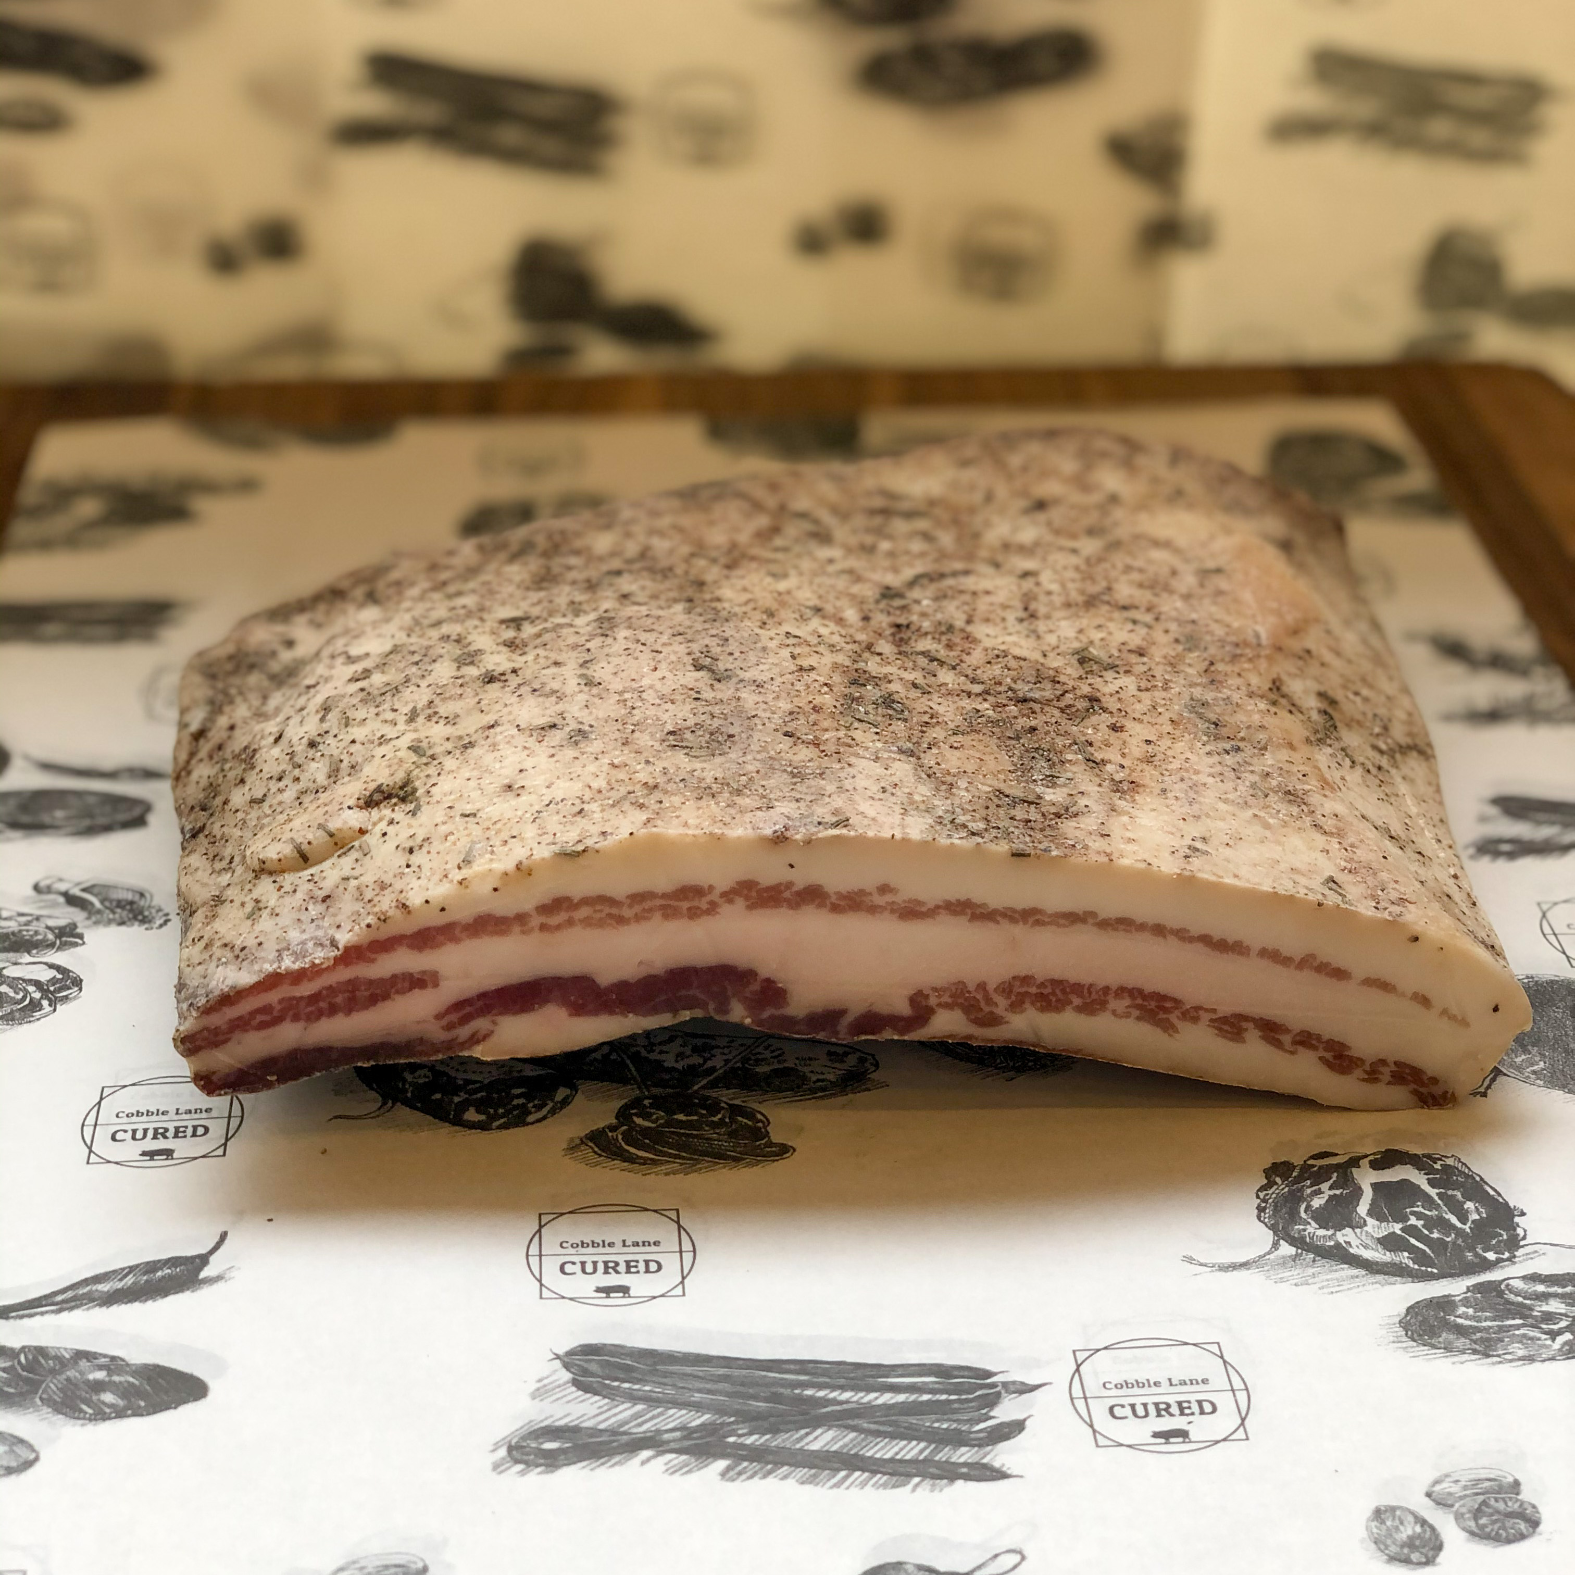

**Ingredients**- British Pork (95.8%), Salt, Cane Sugar, Spices (0.4%) Garlic (0.2%). Preservatives E250 E252. (Pork content 125g per 100g)

**Allergens-** There are no allergens in this product.

**Preservatives**- E250 Sodium Nitrite, E252 Potassium Nitrate

**Meat Supplier**- Dawkins International (GB 2410 & UK 2252)

Dawkins International Ltd is a UK Sow Processor. Established in the 1960’s, they are a family business in the true sense of the word; they are a real family! Together they have championed the need for high animal welfare within the industry which has allowed us to develop into a successful, medium-sized company. With the family friendly culture, they pride ourselves on taking a professional approach, adopting an ‘act now’ attitude in everything they do.

**Date Code Format and Traceability -**Date- DD/MM/YYYY Batch Code- 300316

**Storage once opened**- Keep refrigerated. Sealed in a vacuum sealed pack. Once opened store refrigerated below 8 degree C and consume with in 7 days, Or use by date

**Nutritional-**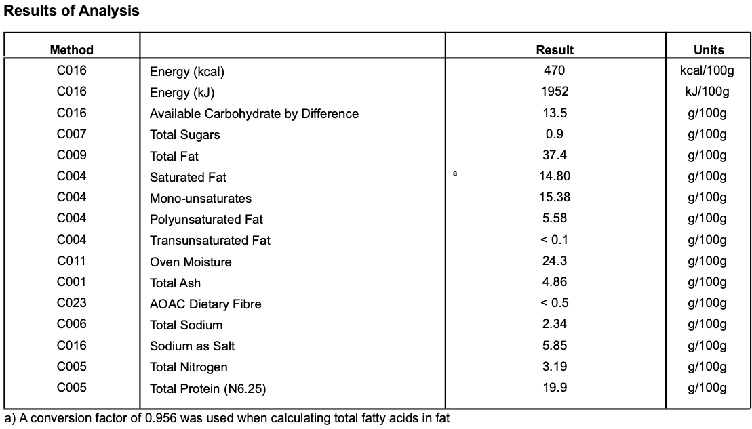

**Microbiological Testing**- Carried out By Intertek Laboratories

**Micro Standard-**

E.Coli <10 Staphylococci <20

Enterobacteriaceae <10 Bacillius Cerus <20

Clostridium <10

Listeria Not Detected Salmonella Not Detected

**Packaging-** Pancettais packaged in High quality food standard vacuum bags 50cm, 30cm, 10cm.The outer packaging is a Cardboard box 40cm, 30cm, 30cm

**Shelf life**- max 4 months min 1 month from Pack Date

**Pack size & Product Code**- 1.2-2.5kg (product code CLC10) - Note it can be cut into half pieces.

**Also available as:**

200g deli packs (product code CLC121). Packed in high quality food grade boards & bags. Size approx 160mmx250mm. Shelf life max 61 days months, min 50 days. Once opened store refrigerated below 8 degree C and consume with in 3 days, Or use by date