**Specification for Guanciale**

An air dried traditional delicacy from the Italian regions of Umbria and Lazio, prepared from British pork jowl / cheeks. May contain string from where the product has been hung up.

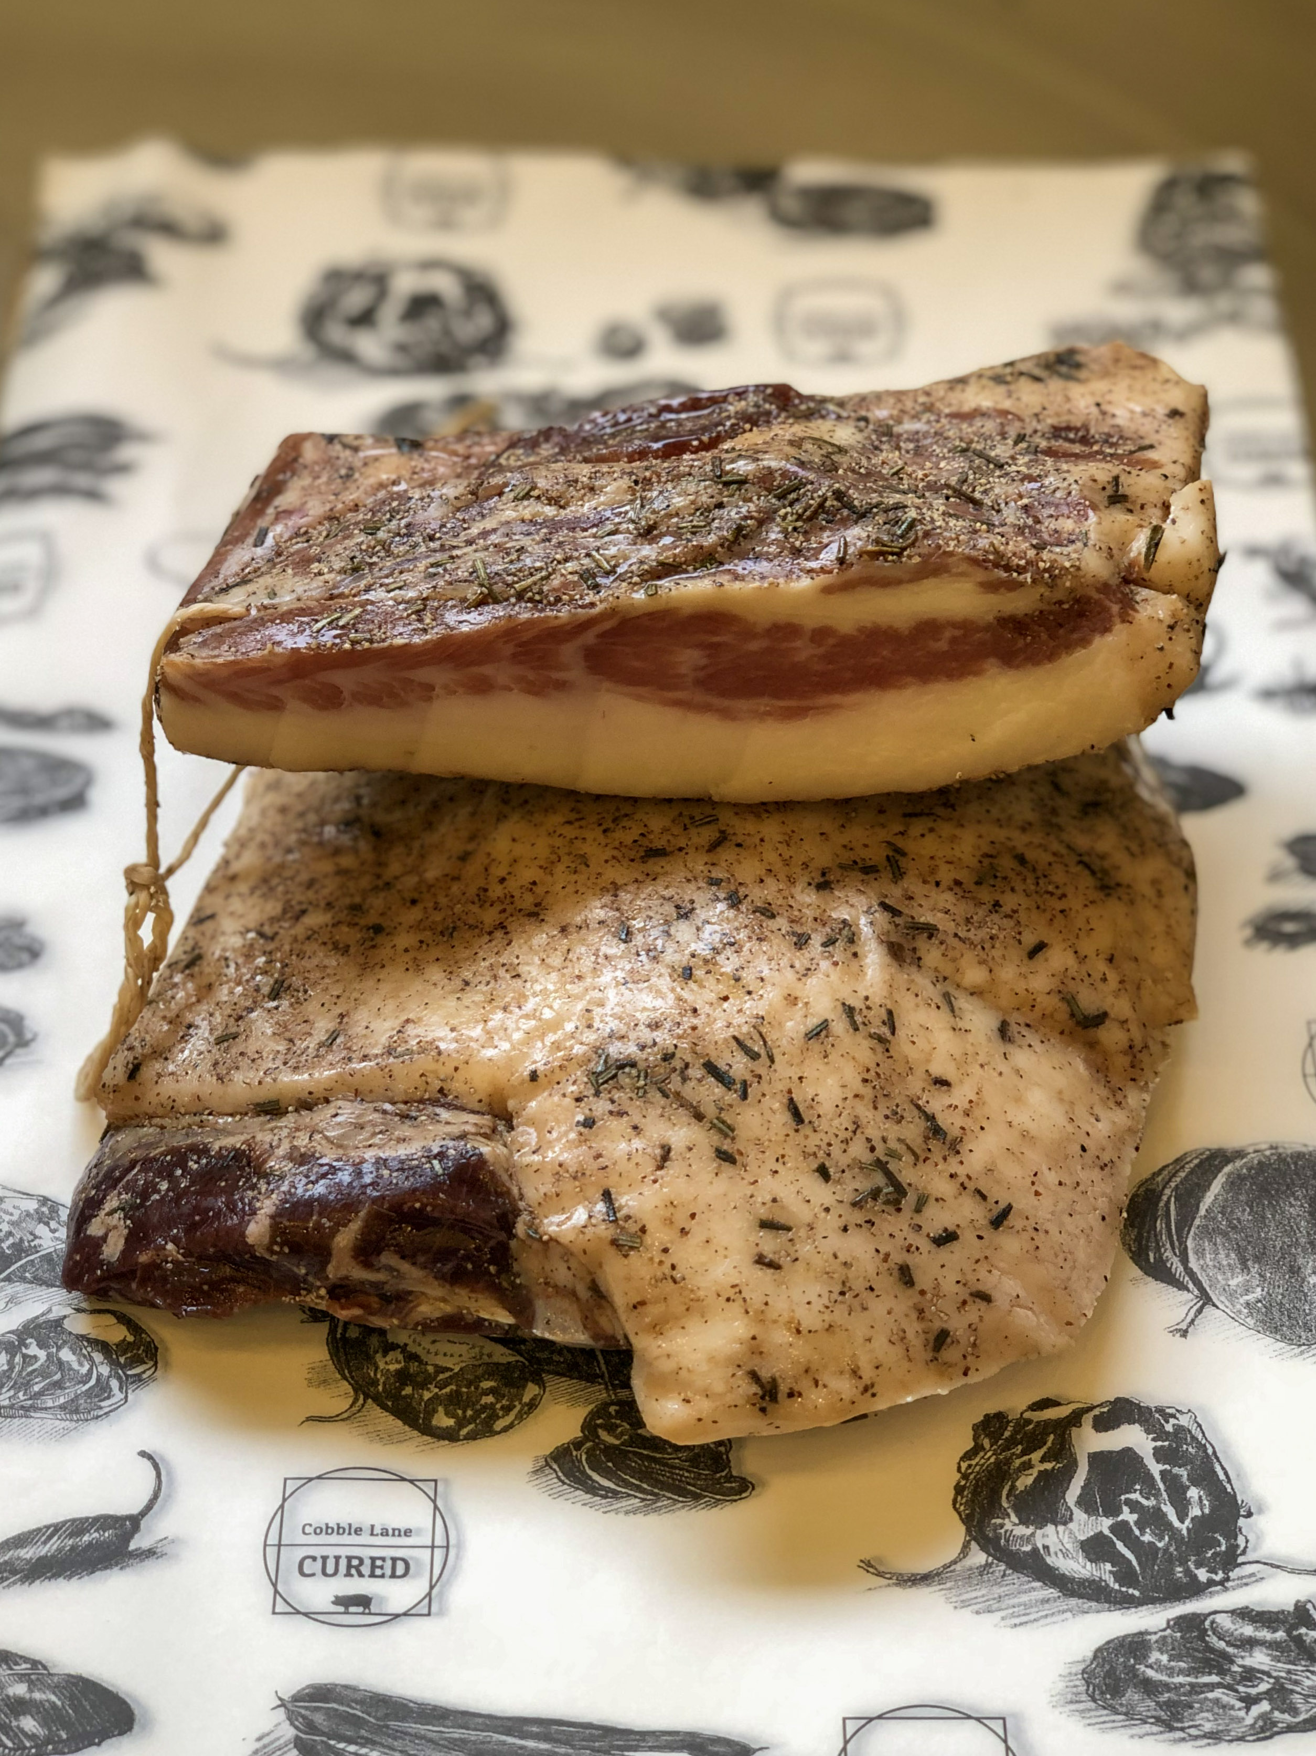

**Ingredients**- British Pork (95.8%), Salt, Cane Sugar, Spices (0.4%) Garlic (0.2%). Preservatives E250 E252. (Pork content 125g per 100g)

**Allergens-** There are no allergens in this product.

**Preservatives**- E250 Sodium Nitrite, E252 Potassium Nitrate

**Nutritional-**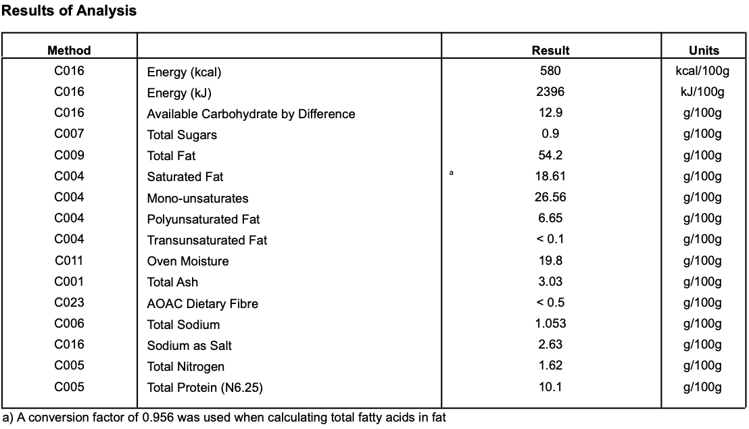

**Meat Supplier**- Taste Tradition (UK 2605)

Taste Tradition connects the farmer and the master butcher in a unique partnership to supply from field to plate across the full range of the highest quality UK meats.

**Date Code Format and Traceability -**Date- DD/MM/YYYY Batch Code- 300316

**Storage once opened**- Sealed in a vacuum sealed pack. Once opened store refrigerated below 8 degree C and consume with in 7 days, Or use by date

**Microbiological Testing**- Carried out By Intertek Laboratories

**Micro Standard-**

E.Coli <10 Staphylococci <20

Enterobacteriaceae <10 Bacillius Cerus <20

Clostridium <10

Listeria Not Detected Salmonella Not Detected

**Packaging-** Guancialeis packaged in High quality food standard vacuum bags 35cm, 25cm, 10cm.The outer packaging is a Cardboard box 40cm, 30cm, 30cm

**Shelf life**- max 4 months, min 1 Months from Pack Date

**Pack size**- 300g - 1kg

**Also available as:**

150-250g deli packs. Also 300-350g deli packs.

Both packed in high quality food grade bags. Size approx 160mmx250mm. Shelf life max 61 days months, min 56 days. Once opened store refrigerated below 8 degree C and consume with in 3 days, Or use by date. Priced by weight.