PIEMONTE DOC CHARDONNAY
“INTRUSO”

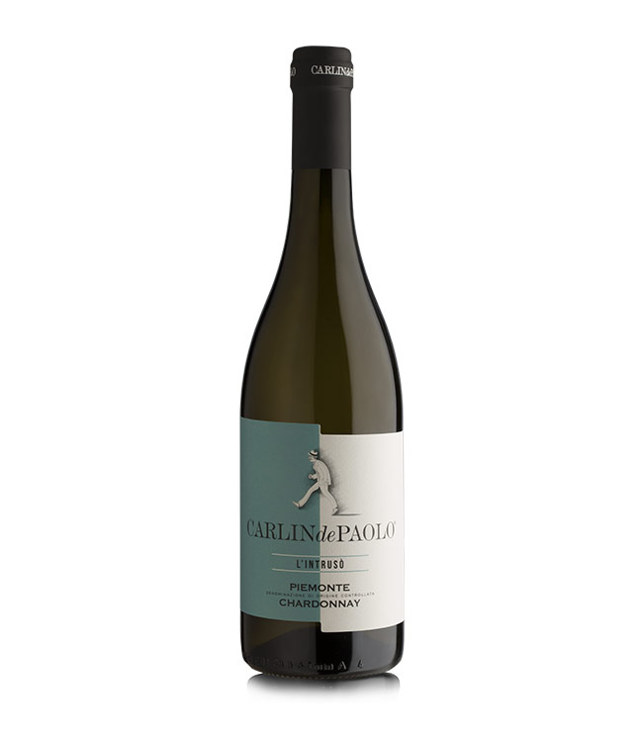
Production zone: Piemonte
Soil: clayey and calcareous
Altitude: 150 – 300 meters above sea level
Training system: guyot
Grape variety: 100% Chardonnay
Production yield per hectare: 100 quintals
Average age of the vines: 20 years
Wine making: At a temperature of 12 ° C for 30 days
Colour: light, straw yellow
Aroma: White field flowers, white peaches and orchard fruit with notes of exotic fruit.
Taste: ample bouquet with notes of white flowers such as peach trees and fruity notes of apple, banana, pineapple and almonds
Alcohol: 12.5%
Food matching: very versatile wine, perfect with white meat, fish and soft cheese


