TERRE ALFIERI ARNEIS DOCG

Production zone: Piemonte
Soil: clayey and calcareous
Altitude: 150 – 300 meters above sea level
Training system: guyot
Grape variety: 100% Arneis
Production yield per hectare: 100 quintals
Average age of the vines: 20 years
Wine making: Grapes are refrigerated until they reach at 0.- 2°C. Fermentation at a low temperature. The wine lies on its yeasts for 5 months with battonage.
Colour: bright, crystal, golden yellow
Aroma: White field flowers, white peaches and orchard fruit with notes of exotic fruit.
Taste: Creamy, Very mineral with notes of honey and exotic fruit, A long lingering mineral aftertaste.
Alcohol: 13.5%
Food matching: this wine perfectly matches with every starter, with light fish and white meat. Serve cool anytime during the day.



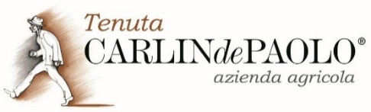
A tasty Arneis with ripe-grapefruit and dry-mineral character. Some honeysuckle notes, too. Quite dense and persistent on the palate. A pleasant bitter tinge at the end.

