Spumante brut metodo charmat

Production zone: Piemonte
Soil: sandy, clayey and calcareous
Altitude: 180 – 300 meters above sea level
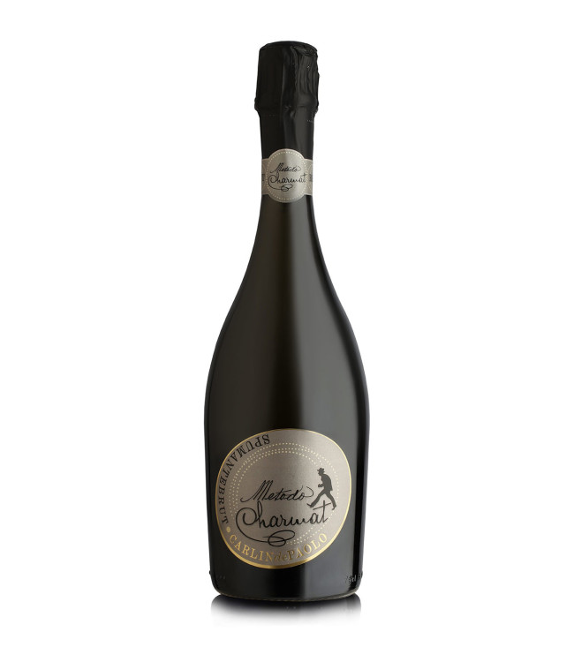
Training system: guyot
Grape variety: Chardonnay, Arneis, (% depends on harvest)
Production yield per hectare: 100 quintals
Average age of the vines: 40 years
Wine making: white wine vinification in stainless steel tanks “ autoclave “ at low temperatures
Colour: straw yellow with soft golden nuances.
Aroma: delicate and elegant, fruity and fragrant with a soft yeasty finish and sensations of crusty bread.
Taste: dry, elegant, fresh, typically sapid and extremely harmonic. Tight-grained, continuous “perlage”, lively and elegant
Alcohol: 12.5%
Food matching: this wine is an excellent aperitif or with every starter, with light fish and white meat. Serve cool anytime during the day



