BAROLO 2019 DOCG

Production zone: Castiglione Falletto

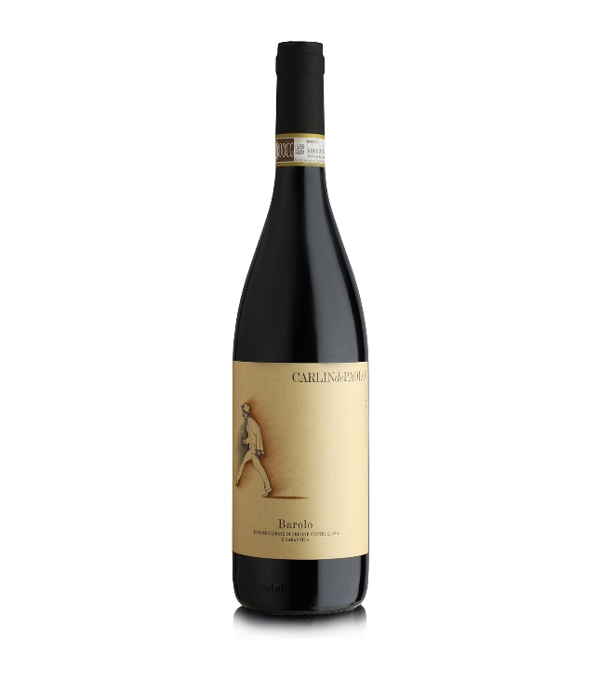Soil: limy, clayey, sandy and calcareous

Altitude: 300 – 350 meters above sea level

Training system: guyot

Grape variety: 100% Nebbiolo

Production yield per hectare: 80 quintals

Average age of the vines: 40 years

Wine making: in steel at a temperature of 28/30° for 10 days of maceration

Maturation: in 30-50 hectolitre French oak barrels for at least 3 years. In bottle for at least 2 years

Colour: garnet red with brick-red nuances

Aroma: intense, complex with sensations of cherry, mint, violet and hot fruity jam.

Taste: ; warm and full-flavoured with dominate features of violet and withered roses.

Palate: dry and soft, with a spicy long finish.

Food matching: Roasted meats, game, mushrooms, peppers, and strong cheeses. Perfect also as a meditation wine

Alcohol: 14%

“Interesting nose with black licorice and almost balsamic notes to the dense dried-strawberry and floral aromas, following through to a full-bodied palate with lots of spicy,

cedary fruit flavor and a long, savory finish.”

