PRODUCT SPECIFICATION
Product Name | Fresh English Wasabi Rhizome 1kg | 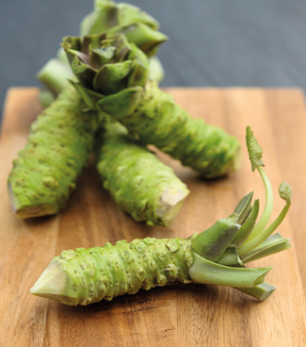
SKU Code | WSB.ENG.03
Version number | 1
Issue Date | 01/07/19
Commodity Code | 0706909000
Country of Origin | UK
Product Description | Wasabia japonica is a member of the Brassica family, which includes cabbages, horseradish and mustard. Large, heart shaped leaves grow on 60cm long stems from the crown of the plant.  The wasabi stem, or rhizome, is formed at the base of the plant and grows upwards above ground taking up to two years to reach maturity. It is this stem which is grated to produce wasabi paste.  Our fresh wasabi is grown in natural, mineral rich water on our Dorset and Hampshire farms.  Sold by Kg
Unit Weight | 1kg (multiple Rhizomes of varied weight) | Unit/Pack Nett Weight | 1.1kg
Unit Dimensions (LxWxH mm) | N/A
Case Weight (kg) | N/A
Case Dimensions (cm) | N/A
Unit Barcode | N/A
Shelf life (days) | 2 weeks from harvest.
Packaging | Cardboard Outer, Recyclable Ice pack
Storage | Keep moist and refrigerated
Ingredient Declaration | 100% Wasabia japonica
Allergy Information | N/A
Nutritional Information per 100g | Energy kj/(kcal) | 321 kj/(76 kcal)
 | Fat | 0.2g
 | - From this saturated Fat | 0g
 | Carbohydrates | 17.4g
 | - From this Sugar | 2.2g
 | Protein | 2.8g
 | Salt (*From Natrium/Sodium) | 0g
Suitable for Vegetarians or Vegans | Yes

Approved By:
Title | Logistics and Operations Manager
Name | Jack McElhinney
Signature | 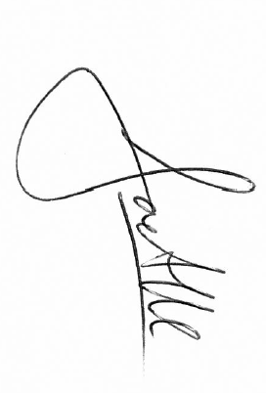
Date | 01/07/19

