Product Specification
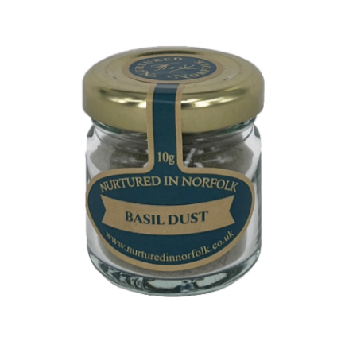
PRODUCT
Name of Product | Basil dusting powder
Legal Name | Basil dried, heat treated and grinded
Scientific Name | Ocimum basilicum
Pack Size | 10 g
Ingredients | Basil 100%
Country of Origin | UK
Allergen Advice | For allergens see ingredients in bold
Supplier | Nurtured in Norfolk
Address | Hillside Nursery, Shipdham Road, Norfolk, NR19 1NP
Telephone Number | 01362 760760
Commercial Contact | orders@nurturedinnorfolk.co.uk
Technical Contact | technical@nurturedinnorfolk.co.uk

SHELF LIFE AND STORAGE CONDITION
Shelf Life | Minimum 3 months
Storage Temperature and Condition | Dry Store, ambient

ORGANOLEPTIC CHARACTERISTIC
Flavour | Subtle with peppery undertones. Earthy, fresh taste
Visual Appearance | Free flowing fine powder.
Colour | Green.
Odour | Minty, peppery anise like notes
Texture | Free flowing powder.

QUALITY & SAFETY
 | Accepted level |  | Unacceptable level
E-Coli | <100 cfu/g |  | >100 cfu/g
Salmonella | Not detectable in 25g |  | Detectable in 25g
Residues (raw material only, not applicable to the dried product) | < GB MRL |  | >GB MRL
Foreign bodies (e.g. stones, pests) | nil |  | present
FOOD TOLERANCE DATA
 |  | Contains |  | Site Handled
Cereals containing gluten (Wheat, rye, barley, oats, spelt, kamut) |  | NO |  | NO
Crustaceans and products thereof |  | NO |  | NO
Molluscs and products thereof (i.e. mussels/ oysters) |  | NO |  | NO
Egg/egg derivatives (i.e. Albumen, lysozyme) |  | NO |  | NO
Fish/fish derivatives |  | NO |  | NO
Milk/milk derivatives |  | NO |  | NO
Soya and soy derivatives |  | NO |  | NO
Mustard/mustard derivatives |  | NO |  | YES
Sulphites (E220-E228) >10mg/kg |  | NO |  | NO
Lupin and products thereof |  | NO |  | NO
Celery/celery derivatives |  | NO |  | YES
Peanut and peanut derivatives |  | NO |  | NO
Nuts (tree nuts: i.e. almond, hazelnut, walnut, cashew, pecan, brazil nut, pistachio, macadamia) and derivatives, including unrefined nut oils |  | NO |  | NO
Sesame seeds/sesame derivatives, including oils |  | NO |  | NO
Coconut /coconut oil |  | NO |  | NO
Pine nuts/pine nut kernels |  | NO |  | NO

SUITABILITY
This product is: | Yes | No | Details
Suitable for Vegans | Yes | No
Suitable for Vegetarians | Yes | No
Suitable for Coeliacs | Yes | No
Suitable for Kosher | Yes | No | Not certified
Suitable for Halal | Yes | No | Not certified

GMO DECLARATION
All raw materials used in production of this product are sourced from non-genetically modified ingredients and have not been exposed to such modification.
Nurtured in Norfolk actively avoid the use of GM materials in their product range and stipulate with their suppliers that all food ingredients and products must not contain any genetically modified organisms or be produced from any genetically modified organisms.

ADDITIONAL INFORMATION
Products manufactured by Nurtured in Norfolk comply with all relevant UK and EU legislation, including but not limited to the Food Safety Act 1990, and subsequent amendments. Systems are in place to satisfy the defence of ''all reasonable precautions and all due diligence''. A documented Quality Management System is in operation.

¶

